|  |
| --- |
| Experiment No. 8 |
| Implement Restoring algorithm using c-programming |
| Name: Harsh Tripathi |
| Roll Number: 59 |
| Date of Performance: |
| Date of Submission: |

**Aim:** To implement Restoring division algorithm using c-programming.

**Objective -**

1. To understand the working of Restoring division algorithm.
2. To understand how to implement Restoring division algorithm using c-programming.

**Theory:**

1) The divisor is placed in M register, the dividend placed in Q register.

2) At every step, the A and Q registers together are shifted to the left by 1-bit

3) M is subtracted from A to determine whether A divides the partial remainder. If it does, then Q0 set to 1-bit. Otherwise, Q0 gets a 0 bit and M must be added back to A to restore the previous value.

4) The count is then decremented and the process continues for n steps. At the end, the quotient is in the Q register and the remainder is in the A register.

**Flowchart**

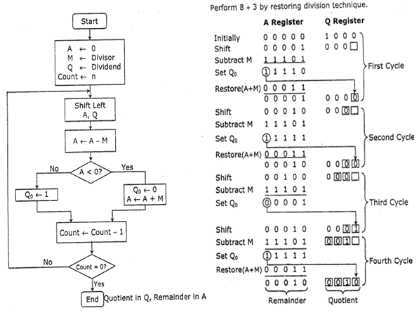

**Program-**

**#include <stdio.h>**

**#include <stdlib.h>**

**int dec_bin(int, int []);**

**int twos(int [], int []);**

**int left(int [], int []);**

**int add(int [], int []);**

**int main()**

**{**

**int a, b, m[4]={0,0,0,0}, q[4]={0,0,0,0}, acc[4]={0,0,0,0}, m2[4], i, n=4;**

**printf("Enter the Dividend: ");**

**scanf("%d", &a);**

**printf("Enter the Divisor: ");**

**scanf("%d", &b);**

**dec_bin(a, q);**

**dec_bin(b, m);**

**twos(m, m2);**

**printf("\nA\tQ\tComments\n");**

**for(i=3; i>=0; i--)**

**{**

**printf("%d", acc[i]);**

**}**

**printf("\t");**

**for(i=3; i>=0; i--)**

**{**

**printf("%d", q[i]);**

**}**

**printf("\tStart\n");**

**while(n>0)**

**{**

**left(acc, q);**

**for(i=3; i>=0; i--)**

**{**

**printf("%d", acc[i]);**

**}**

**printf("\t");**

**for(i=3; i>=1; i--)**

**{**

**printf("%d", q[i]);**

**}**

**printf("_\tLeft Shift A,Q\n");**

**add(acc, m2);**

**for(i=3; i>=0; i--)**

**{**

**printf("%d", acc[i]);**

**}**

**printf("\t");**

**for(i=3; i>=1; i--)**

**{**

**printf("%d", q[i]);**

**}**

**printf("_\tA=A-M\n");**

**if(acc[3]==0)**

**{**

**q[0]=1;**

**for(i=3; i>=0; i--)**

**{**

**printf("%d", acc[i]);**

**}**

**printf("\t");**

**for(i=3; i>=0; i--)**

**{**

**printf("%d", q[i]);**

**}**

**printf("\tQo=1\n");**

**}**

**else**

**{**

**q[0]=0;**

**add(acc, m);**

**for(i=3; i>=0; i--)**

**{**

**printf("%d", acc[i]);**

**}**

**printf("\t");**

**for(i=3; i>=0; i--)**

**{**

**printf("%d", q[i]);**

**}**

**printf("\tQo=0; A=A+M\n");**

**}**

**n--;**

**}**

**printf("\nQuotient = ");**

**for(i=3; i>=0; i--)**

**{**

**printf("%d", q[i]);**

**}**

**printf("\tRemainder = ");**

**for(i=3; i>=0; i--)**

**{**

**printf("%d", acc[i]);**

**}**

**printf("\n");**

**return 0;**

**}**

**int dec_bin(int d, int m[])**

**{**

**int b=0, i=0;**

**for(i=0; i<4; i++)**

**{**

**m[i]=d%2;**

**d=d/2;**

**}**

**return 0;**

**}**

**int twos(int m[], int m2[])**

**{**

**int i, m1[4];**

**for(i=0; i<4; i++)**

**{**

**if(m[i]==0)**

**{**

**m1[i]=1;**

**}**

**else**

**{**

**m1[i]=0;**

**}**

**}**

**for(i=0; i<4; i++)**

**{**

**m2[i]=m1[i];**

**}**

**if(m2[0]==0)**

**{**

**m2[0]=1;**

**}**

**else**

**{**

**m2[0]=0;**

**if(m2[1]==0)**

**{**

**m2[1]=1;**

**}**

**else**

**{**

**m2[1]=0;**

**if(m2[2]==0)**

**{**

**m2[2]=1;**

**}**

**else**

**{**

**m2[2]=0;**

**if(m2[3]==0)**

**{**

**m2[3]=1;**

**}**

**else**

**{**

**m2[3]=0;**

**}**

**}**

**}**

**}**

**return 0;**

**}**

**int left(int acc[], int q[])**

**{**

**int i;**

**for(i=3; i>0; i--)**

**{**

**acc[i]=acc[i-1];**

**}**

**acc[0]=q[3];**

**for(i=3; i>0; i--)**

**{**

**q[i]=q[i-1];**

**}**

**}**

**int add(int acc[], int m[])**

**{**

**int i, carry=0;**

**for(i=0; i<4; i++)**

**{**

**if(acc[i]+m[i]+carry==0)**

**{**

**acc[i]=0;**

**carry=0;**

**}**

**else if(acc[i]+m[i]+carry==1)**

**{**

**acc[i]=1;**

**carry=0;**

**}**

**else if(acc[i]+m[i]+carry==2)**

**{**

**acc[i]=0;**

**carry=1;**

**}**

**else if(acc[i]+m[i]+carry==3)**

**{**

**acc[i]=1;**

**carry=1;**

**}**

**}**

**return 0;**

**}**

**Output -**

Enter the Dividend: 12

Enter the Divisor: 2

A Q Comments

0000 1100 Start

0001 100_ Left Shift A,Q

1111 100_ A=A-M

0001 1000 Qo=0; A=A+M

0011 000_ Left Shift A,Q

0001 000_ A=A-M

0001 0001 Qo=1

0010 001_ Left Shift A,Q

0000 001_ A=A-M

0000 0011 Qo=1

0000 011_ Left Shift A,Q

1110 011_ A=A-M

0000 0110 Qo=0; A=A+M

Quotient = 0110 Remainder = 0000

**Conclusion -**

In conclusion, the implementation of the Restoring Division Algorithm using the C programming language offers a powerful method for efficient and precise division operations. Through this project, we have explored the intricacies of this algorithm, emphasizing its significance in modern computing. By leveraging C's robust features and versatility, we have successfully translated the theoretical framework of the Restoring Division Algorithm into a functional codebase. As a result, we have not only deepened our understanding of division algorithms but also honed our programming skills.